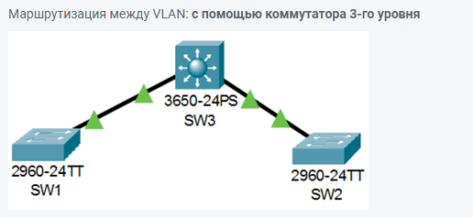

Общее количество компьютеров N = 41

3 VLAN:  VLAN 15, VLAN 25, VLAN 35

Сеть IP-адресации: 172.16.n.0/24

Вариант сети n=90

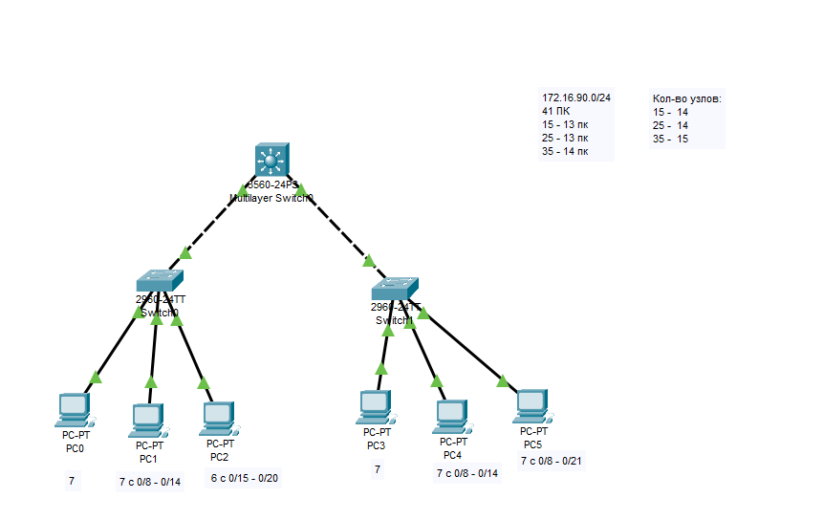

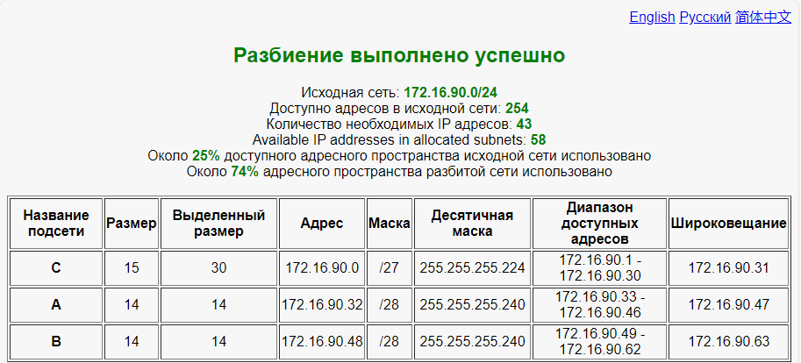

Switch(config)#int range fa0/1-7

Switch(config-if-range)#sw access vlan 15

% Access VLAN does not exist. Creating vlan 15

Switch(config-if-range)#

%CDP-4-NATIVE_VLAN_MISMATCH: Native VLAN mismatch discovered on FastEthernet0/1 (15), with Switch FastEthernet0/1 (1).

ex

Switch(config)#int range fa0/8-14

Switch(config-if-range)#sw access vlan 25

% Access VLAN does not exist. Creating vlan 25

Switch(config-if-range)#

%CDP-4-NATIVE_VLAN_MISMATCH: Native VLAN mismatch discovered on FastEthernet0/1 (15), with Switch FastEthernet0/1 (1).

ex

Switch(config)#int range fa0/15-20

Switch(config-if-range)#sw access vlan 35

% Access VLAN does not exist. Creating vlan 35

Switch(config-if-range)#ex